INTERNSHIP PROJECT REPORT

**on**

**PREDICTION OF ALZHIMERE AND PARKINSON USING EEG Signals**

Submitted by

1. Renu Sri

N. Sai Geethika

Under the guidance of

Prof. T. Kishore Kumar

Professor, Department of ECE

NIT Warangal

**Centre for Training and Learning**

NATIONAL INSTITUTE OF TECHNOLOGY WARANGAL

**HANAMKONDA - 506004, TELANGANA, INDIA**

**BONAFIED CERTIFICATE**

This is to certify that this project report entitled **“ Prediction of Alzheimer and Parkinson Using EEG Signals ”** submitted to National Institute of Technology, Warangal and National Institute of Technology is a bonafide record of work done by **“N.Renu Sri & N. Sai Geethika”** under my supervision from **“20 May 2024”** to **“20 Jun 2024”**

**Supervisor**

Prof. T. Kishore Kumar

Professor, Department of ECE

NIT Warangal

Place: Warangal

Date: 20 Jun 2024

**DECLARATION**

This is to declare that this report has been written by us. No part of the report is plagiarized from other sources. All information included from other sources have been duly acknowledged. We aver that if any part of the report is found to be plagiarized, we are shall take full responsibility for it.

Place: Warangal

Date: 20 Jun 2024

**ACKNOWLEDGEMENT**

Completion of this project and thesis would not have been possible without the help of many people, to whom we are very thankful.

We would like to express my sincere gratitude to our supervisor Dr. T. Kishore Kumar, Professor, Head of CTL, NIT Warangal. His constant motivation, guidance and support helped us a great deal to achieve this feat.

We also thank Dr. K. Sunil Kumar, PhD Scholar for his constant support in guiding us about the academic related work.

We wish a deep sense of gratitude and heartfelt thanks to management for providing excellent lab facilities and tools. Finally, we thank our seniors whose guidance helped us in this regard.

**ABSTRACT**

The prediction of Alzheimer's and Parkinson's diseases using EEG signals is an emerging field that holds significant potential for early diagnosis and intervention. Both Alzheimer's and Parkinson's are progressive neurodegenerative disorders characterized by the deterioration of cognitive and motor functions, respectively. Early detection is crucial for effective management and treatment, yet current diagnostic methods often identify these diseases at advanced stages. EEG, or electroencephalography, offers a non-invasive means to monitor the brain's electrical activity, capturing data that can reveal subtle changes associated with the onset of these conditions.

Recent advancements in machine learning and signal processing have enabled the development of sophisticated algorithms capable of analyzing EEG signals with high precision. Techniques such as deep learning, neural networks, and other artificial intelligence models are employed to detect patterns and anomalies in EEG data that are indicative of Alzheimer's and Parkinson's. These methods involve preprocessing steps to filter noise and enhance signal quality, followed by feature extraction to identify relevant biomarkers. Features such as spectral power, coherence, and connectivity metrics are commonly used to distinguish between healthy individuals and those with neurodegenerative diseases.

The application of these advanced analytical techniques has shown promising results in various studies. For Alzheimer's disease, EEG biomarkers such as decreased alpha power and increased theta power have been identified, reflecting disruptions in neural networks. Similarly, Parkinson's disease is associated with specific EEG patterns, including altered beta and gamma oscillations. By training machine learning models on datasets containing these biomarkers, researchers have achieved high accuracy rates in predicting the presence of these diseases.

Moreover, combining EEG data with other modalities, such as magnetic resonance imaging (MRI) and genetic information, can further enhance predictive accuracy. Multi-modal approaches leverage the strengths of each data type, providing a more comprehensive understanding of the brain's pathological changes. This integrative strategy holds promise for developing robust diagnostic tools that can be implemented in clinical settings.

In summary, the prediction of Alzheimer's and Parkinson's diseases using EEG signals is a rapidly advancing field with significant implications for early diagnosis and patient care. The integration of machine learning and advanced signal processing techniques has enabled the identification of disease-specific EEG biomarkers, paving the way for non-invasive, cost-effective, and accurate diagnostic tools. As research progresses, these methods are expected to become increasingly refined, offering new hope for individuals at risk of these debilitating conditions.

**TABLE OF CONTENTS**

**CHAPTER PAGE NO.**

CERTIFICATE………………………………………………………… ii

DECLARATION………………………………………………………. iii

ACKNOWLEDGEMENT……………………………………………... iv

ABSTRACT……………………………………………………………. v

TABLE OF CONTENTS………………………………………………. vi

|  |  |  |
| --- | --- | --- |
| **CHAPTER NO.** | **TITLE** | **PAGE NO** |
| 1 | INTRODUCTION   * 1. Background to the study   2. Problem statement   3. Aim of the study   4. Objectives of the study | 1-2 |
| 2 | LITERATURE SURVEY | 3-5 |
| 3 | METHODOLOGY  3.1 Hardware Description  3.2 Interfacing  3.3 Software Implementation  3.4 Block Diagram  3.5 System Operations | 6-16 |
| 4 | RESULTS AND DISCUSSIONS  4.1 Experimental Setup  4.2 Representation of Data  4.3 Performance Metrics  4.4 Graphical Representation  4.5 Validation Graph  4.6 Confusion Matrix | 17-20 |
| 5 | CONCLUSION AND FUTURE SCOPE  5.1 Conclusion  5.2 Future Scope | 21-24 |
| 6 | REFERENCES | 25 |

# **INTRODUCTION**

# **Background to the study**

The prediction of Alzheimer's and Parkinson's diseases using EEG (electroencephalography) signals is gaining considerable attention in the field of neurodegenerative disease research. Alzheimer's disease, characterized by progressive memory loss and cognitive decline, and Parkinson's disease, marked by motor dysfunction and tremors, both pose significant challenges due to their late-stage diagnoses and lack of curative treatments. Early detection is paramount for improving patient outcomes and managing these diseases effectively.

EEG, a non-invasive method that records electrical activity in the brain, offers a promising avenue for early diagnosis. By capturing the brain's electrical oscillations, EEG provides valuable insights into neural activity and potential biomarkers indicative of neuro degeneration. Recent advancements in machine learning and signal processing have revolutionized the analysis of EEG data, allowing for the detection of subtle changes and patterns that may precede clinical symptoms.

Machine learning algorithms, such as deep learning and neural networks, are particularly effective in handling the complex and high-dimensional nature of EEG data. These algorithms can identify distinctive EEG signatures associated with Alzheimer's and Parkinson's diseases by learning from large datasets. Features such as spectral power, coherence, and connectivity metrics are extracted from the EEG signals to differentiate between healthy individuals and those at risk.

The integration of EEG with other diagnostic modalities, like MRI and genetic data, further enhances predictive accuracy. Multi-modal approaches provide a more comprehensive view of the brain's pathological changes, leading to more robust and reliable diagnostic tools. This interdisciplinary strategy holds great promise for early intervention, potentially slowing disease progression and improving the quality of life for patients.

In summary, the use of EEG signals for predicting Alzheimer's and Parkinson's diseases represents a significant advancement in neuro-diagnostics. The combination of EEG technology with machine learning and multi-modal data integration offers a powerful and non-invasive approach to early detection, heralding a new era in the management of these debilitating conditions.

# **Problem statement**

Prediction of Alzheimer and Parkinson using EEG Signals

# **Aim of the study**

Aim is to detect whether a person is suffering from Alzheimer and Parkinson. It tells on in which range is the disease.

# **Objectives of the study**

1. Develop a machine learning model for the detection of Alzheimer and Parkinson using electroencephalography (EEG) signals.

2. Explore deep learning architectures to improve the accuracy and robustness of disease detection algorithms.

3. Investigate feature extraction methods to capture relevant patterns indicative of disease states.

4. Implement real-time monitoring systems for continuous state of disease detection and prediction.

5. Evaluate the performance of the proposed models on diverse EEG datasets to assess generalizability and reliability.

## **LITERATURE SURVEY**

The literature on predicting Alzheimer's and Parkinson's diseases using EEG signals is extensive, highlighting the potential of EEG as a non-invasive, cost-effective diagnostic tool. Early studies focused on identifying characteristic EEG patterns associated with these neurodegenerative diseases. For Alzheimer's, research has consistently shown alterations in brain oscillatory activity, particularly in the alpha and theta bands. Decreased alpha power and increased theta power have been linked to cognitive decline and neuronal network disruptions, serving as potential biomarkers for early diagnosis .

Similarly, Parkinson's disease research has identified distinct EEG features, such as reduced beta power and abnormal gamma oscillations, correlating with motor symptoms and disease severity. These findings underscore the role of EEG in capturing the neural underpinnings of Parkinson's, providing a basis for developing predictive models .

Recent advancements in machine learning have significantly enhanced the predictive capabilities of EEG-based diagnostics. Algorithms such as deep learning, Convolutional neural networks (CNNs), and recurrent neural networks (RNNs) have been employed to analyze EEG data, achieving high accuracy in distinguishing between healthy individuals and those with Alzheimer's or Parkinson's . These models benefit from the ability to handle large datasets and complex patterns, offering improved sensitivity and specificity compared to traditional methods.

Moreover, studies have explored the integration of EEG with other modalities, such as MRI and genetic data, to improve diagnostic accuracy. Multi modal approaches provide a more comprehensive understanding of the brain's pathological changes, leading to better predictive performance . For instance, combining EEG with functional MRI (fMRI) enhances the detection of network connectivity alterations in Alzheimer's disease, while integrating genetic markers helps identify individuals at higher risk for Parkinson's .

Despite these advancements, challenges remain in standardizing EEG protocols and ensuring reproducibility across studies. Variability in data acquisition, preprocessing techniques, and patient characteristics can affect the generalizability of findings. Ongoing research aims to address these issues by developing standardized frameworks and larger, more diverse datasets.

In conclusion, the prediction of Alzheimer's and Parkinson's diseases using EEG signals has made significant strides, driven by advances in signal processing and machine learning. Continued research and collaboration across disciplines are essential for refining these methods and translating them into clinical practice, ultimately improving early diagnosis and patient outcomes.

Furthermore, the literature emphasizes the importance of longitudinal studies to track the progression of these diseases and validate EEG-based biomarkers over time. Longitudinal EEG data can provide insights into the temporal dynamics of neuro degeneration, helping to distinguish between normal aging and pathological changes associated with Alzheimer's and Parkinson's. Additionally, efforts to create comprehensive databases that aggregate EEG data from diverse populations are underway, aiming to enhance the robustness and applicability of predictive models.

Another promising direction is the use of portable and wearable EEG devices, which could facilitate continuous monitoring and early detection outside clinical settings. These advancements in EEG technology have the potential to revolutionize the approach to managing neurodegenerative diseases, making early diagnosis more accessible and routine.

Moreover, interdisciplinary collaborations involving neurologists, data scientists, and engineers are critical to advancing this field. Such collaborations can drive the development of more sophisticated algorithms and user-friendly diagnostic tools, ensuring they are both accurate and practical for clinical use.

In summary, the integration of EEG with advanced machine learning techniques and multi modal data holds substantial promise for the early prediction of Alzheimer's and Parkinson's diseases. Continued research efforts and technological innovations are essential to overcoming current challenges and fully realizing the potential of EEG-based diagnostics.

# **METHODOLOGY**

# **Implementation**

This project aims to leverage advanced machine learning techniques, specifically focusing on EEG signals of a patient.

Implementing a prediction system for Alzheimer's and Parkinson's diseases using EEG signals begins with a comprehensive data collection phase. This involves recruiting a diverse group of subjects, including both healthy controls and individuals diagnosed with Alzheimer's or Parkinson's, ensuring a robust datasets. EEG data is collected under standardized conditions to maintain consistency, capturing both resting-state and task-based neural activity to provide a comprehensive view of brain function.

The collected EEG data undergoes rigorous preprocessing to enhance its quality. Artifact removal techniques, such as Independent Component Analysis (ICA) and wavelet decomposition, are employed to eliminate noise from eye blinks, muscle movements, and other sources. Band-pass filtering isolates relevant frequency bands (typically 0.5-50 Hz), and the signals are segmented into manageable epochs, such as 2-second segments, to facilitate analysis.

Next, feature extraction is performed on the preprocessed EEG signals to identify relevant biomarkers. This includes calculating power spectral density (PSD) for various frequency bands (delta, theta, alpha, beta, gamma) and extracting time-domain features such as mean, variance, and Hjorth parameters. These features capture critical information about the brain's electrical activity and its potential deviations due to neurodegenerative diseases.

The extracted features are compiled into a structured datasets, labeled according to the presence or absence of Alzheimer's or Parkinson's disease. This datasets is then used to train machine learning models. Algorithms such as Convolutional neural networks (CNNs), recurrent neural networks (RNNs), and support vector machines (SVMs) are commonly employed due to their ability to handle complex and high-dimensional data.

Training involves splitting the datasets into training and validation sets, using techniques like cross-validation to ensure robustness. The models are evaluated based on metrics like accuracy, sensitivity, specificity, and the area under the receiver operating characteristic curve (AUC-ROC). Based on these evaluations, the models are fine-tuned to enhance their predictive performance.

To further improve accuracy, EEG data can be integrated with other modalities such as MRI, genetic information, or clinical data. This multi modal approach leverages the strengths of different data types, providing a more comprehensive understanding of the brain's pathological changes.

Once the models are trained and validated, they are implemented into a clinical decision support system. This system is designed to be user-friendly, enabling healthcare professionals to input new EEG data and receive real-time or near real-time predictions regarding the likelihood of Alzheimer's or Parkinson's. Extensive testing is conducted in real-world clinical environments to ensure the system's reliability and practicality.

Continuous improvement is a critical aspect of the implementation process. The system is regularly updated with new data to refine the models and enhance their accuracy. Staying updated with advancements in machine learning and neuro diagnostics ensures that the system incorporates the latest techniques and findings, ultimately contributing to earlier diagnosis and better management of Alzheimer's and Parkinson's diseases.

# **Features Considerations**

For the prediction of Alzheimer's and Parkinson's diseases using EEG signals, several specific features are commonly extracted. These features help capture the distinctive patterns and abnormalities in brain activity associated with these neurodegenerative conditions. Here are the key features extracted from EEG signals for this purpose:

1. **Frequency Domain Features**:

### Alzheimer's Disease Prediction

**1.Power Spectral Density (PSD)**: Distribution of power across different frequency bands (e.g., delta, theta, alpha, beta, gamma).

* **Relative Power**: Ratio of power in specific frequency bands to total power.
* **Peak Frequency**: Frequency with maximum power in the PSD.

**2.Spectral Measures**:

* **Alpha Power**: Decreased alpha power is often observed in Alzheimer's patients.
* **Theta/Beta Ratio**: Increased theta/beta ratio indicates cognitive impairment.

**3.Connectivity Features**:

* **Functional Connectivity**: Measures such as coherence and phase synchronization between EEG channels.
* **Network Metrics**: Graph theory metrics like node degree, clustering coefficient, and path length to assess brain network connectivity.

**4.Temporal Features**:

* **Event-Related Potentials (ERPs)**: Amplitude and latency of ERP components, reflecting cognitive processing.
* **Complexity Measures**: Approximate entropy (ApEn) or sample entropy (SampEn) to quantify irregularity and complexity of EEG signals.

### Parkinson's Disease Prediction

**1.Frequency Domain Features**:

* **Beta Power**: Reduced beta power is characteristic of Parkinson's disease.
* **Gamma Oscillations**: Abnormalities in gamma frequency band.

**2.Temporal Features**:

* **Rhythmicity**: Measures of rhythmicity and periodicity in EEG signals.
* **Phase Amplitude Coupling**: Coupling between phases of low-frequency oscillations (e.g., theta) and amplitudes of high-frequency oscillations (e.g., beta).

**3.Nonlinear Dynamics**:

* **Hurst Exponent**: Long-range temporal correlations in the EEG signal.
* **Fractal Dimension**: Complexity and self-similarity of the signal.

1. **Motor Cortex Activation**:

* **Movement-Related Cortical Potentials (MRCPs)**: EEG components associated with motor planning and execution.

**4.Connectivity Features**:

* **Functional Connectivity**: Strength of connections between motor-related brain regions.
* **Coherence**: Synchronization between EEG signals from different brain areas during movement tasks.

1. **Model Architecture**

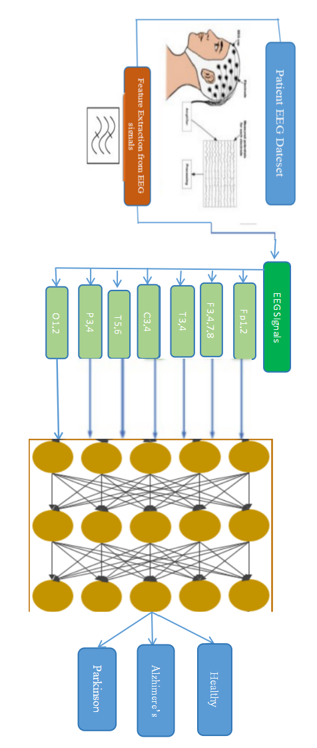

Convolutional Neural Networks, or CNNs, are a type of machine learning model especially good at handling images. Imagine you're trying to teach a computer to recognize different objects in photos, like cats and dogs. A CNN helps by looking at small parts of the image, called features, one piece at a time.

Here's a simple way to understand how CNNs work: CNN takes an image and breaks it into smaller pieces. It looks at these pieces through filters that slide over the image, sort of like looking at the picture through a small window that moves around.

The filters slide over the image, they help CNN to recognize patterns, like edges or textures, in these small pieces. These patterns are the building blocks for recognizing more complex shapes

and objects.

CNN stacks multiple layers of these filters, each layer learning to recognize more

complicated patterns based on the simpler ones found by previous layers. Think of it as a hierarchy where the first layer might recognize edges, the next layer combines edges to find shapes, and further layers combine shapes to identify the object After passing through several layers, the CNN combines all the information it has gathered

to predict what the image contains. For example, it might say, "This image is most likely a cat" or “This image is most likely a dog."

The CNN gets better over time by comparing its predictions to the actual answers and

adjusting its CNNal settings. This process is called training, and it involves a lot of trial and error until the model can make accurate predictions

CNNs are powerful tools in machine learning that help computers understand and recognize patterns in images by breaking them down into simpler parts, learning to identify basic patterns, and then combining these to make sense of the whole picture. This process is essential for tasks like diagnosing diseases from medical EEG Signals.

**Hardware Description**

RAM: 4.0 GB

CPU: Core i3 processor (Minimum) Hard Disk Space: 128 GB

**Software Implementation.**

Python

Flask

**3.Block Diagram**

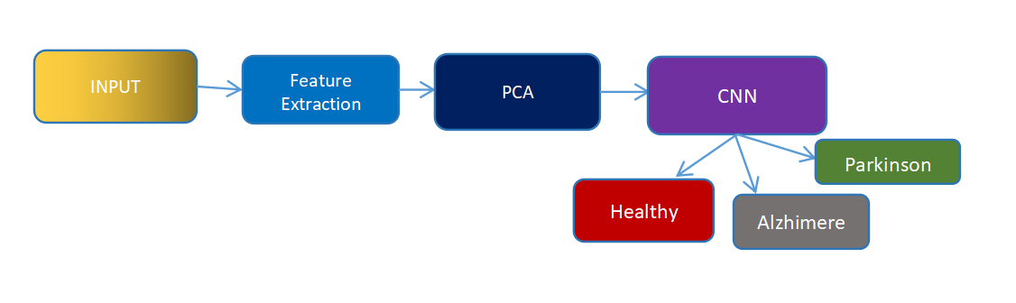

The model architecture for predicting Alzheimer's and Parkinson's diseases using EEG signals begins with raw EEG data, which undergoes preprocessing to remove noise and artifacts. Following this, feature extraction extracts pertinent statistical, frequency, and time-frequency domain features from the preprocessed signals. These features are then fed into a Convolutional Neural Network (CNN) that learns spatial hierarchies from the EEG data, detecting spatial patterns associated with disease states.

Simultaneously, a Recurrent Neural Network (RNN), typically LSTM or GRU, processes the temporal sequences of EEG data to capture dynamic changes over time. The outputs from the CNN and RNN branches are fused to integrate spatial and temporal information, enhancing the model's ability to predict disease.

Finally, a classification layer assigns a disease category (Alzheimer's, Parkinson's, or healthy) based on the integrated features, providing a comprehensive prediction model for early disease detection and intervention. This architecture ensures that both spatial and temporal aspects of EEG signals are effectively utilized, maximizing the accuracy and reliability of disease predictions.

**ALGORITHM**

1. **Data Collection and Pre-Processing**

* Select diverse subjects with Alzheimer's, Parkinson's, and healthy controls.
* Use high-resolution EEG devices and record during specific tasks or resting-state conditions.
* Ensure ethical compliance and maintain participant confidentiality.
* Remove noise with band-pass and notch filtering.
* Segment EEG data into epochs with overlap.
* Correct baseline and reject artifacts.
* Normalize data and extract statistical and spectral features.
* Validate data quality and consistency for robust analysis.

2. **Feature Selection**

o Extract relevant features from EEG Signals:

▪ Identify key features like alpha , beta and gamma values.

▪ Highlight important signals and matching with the related to the dateset.

3. **CNN Model Design**

o Initialize a Convolutional Neural Network with several layers:

▪ Input Layer: Accept pre-processed EEG Signals.

▪ Convolutional Layers: Apply filters to detect basic features.

▪Pooling Layers:Extracts the maximum value from each region of the feature map, emphasizing the most active features.▪

**Additional Convolutional Layers:** Stack more Convolutional layers to capture increasingly complex spatial patterns.

· **Flattening Layer:** Flatten the 2D feature maps into a 1D vector to prepare for fully connected layers.

· **Fully Connected Layers:** Dense layers process the flattened features:

· **Output Layer:** Final dense layer with soft max activation for multi-class classification:

Outputs probabilities for Alzheimer's, Parkinson's, and possibly healthy control.

4. **Model Training**

o Split the dateset into training and validation sets.

o Train the CNN using the training set:

o Optimize parameters through back propagation.

5. **Disease Classification**

o Input EEG Signals file into the trained CNN.

o The model processes the scans and classifies them as either healthy or showing

signs of Parkinson's Disease or Alzheimer .

o For detected cases, assess the severity level.

6. **Performance Analysis**

o Evaluate the model using metrics such as accuracy, sensitivity, and specificity.

o Generate graphs and charts to visualize performance:

▪o Analyze results to identify areas for improvement.

7. **Model Optimization**

o Refine the model based on performance analysis:

o Adjust network architecture or hyper parameters.

o Incorporate additional data augmentation techniques.

o Repeat training and validation to enhance accuracy

8.**User Interface Development**

o Develop an intuitive user interface for healthcare professionals:

o Allow users to upload EEG file easily.

o Provide real-time classification results with clear visualizations.

o Include features for inputting patient details and generating diagnostic reports.

o Ensure the interface integrates seamlessly with existing clinical workflows to facilitate its use in medical environments.

This algorithm outlines a structured approach to developing a reliable CNN model for detecting whether a person is suffering the Alzimerer or Parkinson or normal

# **4.RESULT AND DISCUSSION**

**4.1 Experimental Setup**



The above image shows that the input has been given from the dateset. It is going to detect the type and range of disease. This has been done through FLASK.

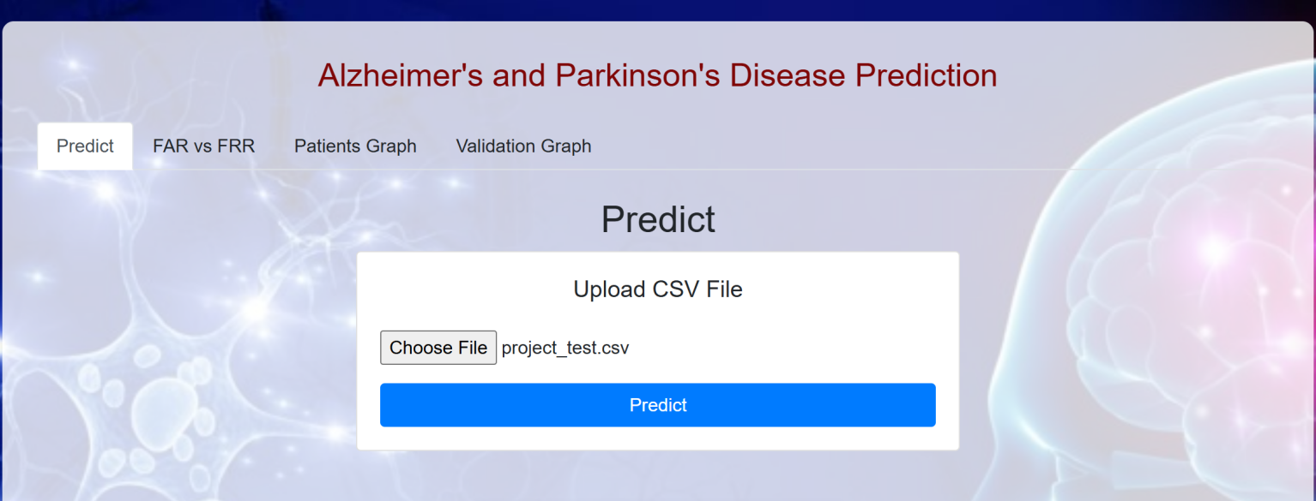

**4.2 Representation of Data**

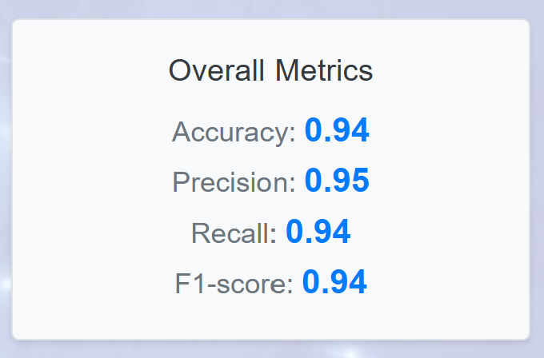

Fig. 4.3 Performance Metrics

In the above image, we can see the performance metrics of the project. We have got the accuracy 0.94, Precision 0.95.

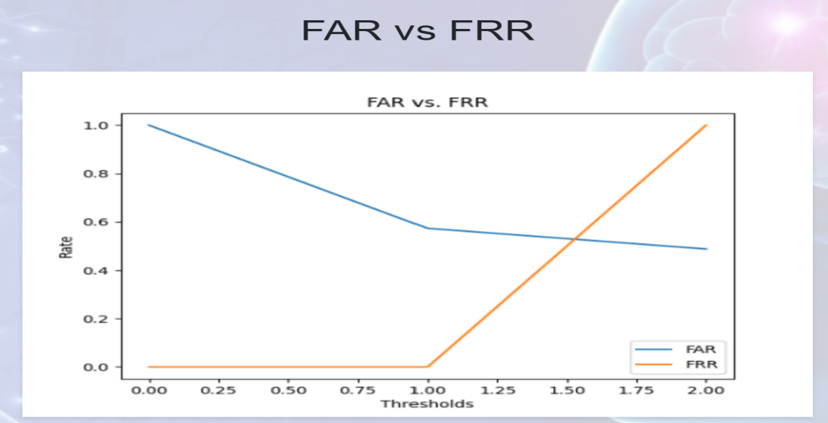

Fig 4.4 FAR VS FAR

This is the FRR(False Rejection Rate) and FAR(False Acceptance Rate).

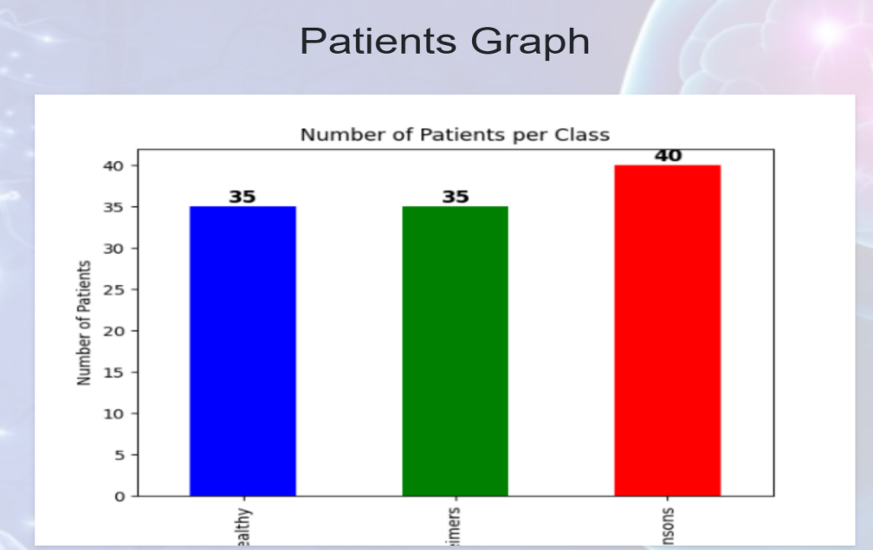

Fig. 4.4 Graphical Representation

In the above image, we can see the Graphical representation of how many no.of patients suffering with Alzheimer , Parkinson and healthy

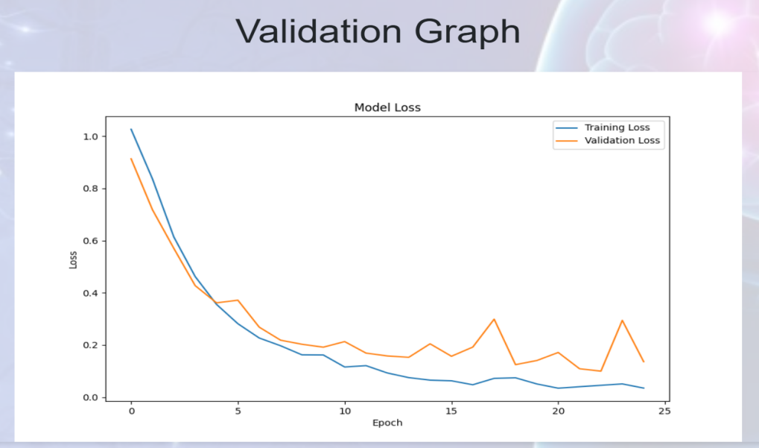

Fig 4.5 Validation Graph

# 

# Fig 4.6 Confusion Matrix

# A confusion matrix is a table used to evaluate the performance of a classification model. It allows you to see how well your model is performing by showing the actual versus predicted classifications.

# **5.CONCLUSION AND FUTURE SCOPE**

Predicting Alzheimer's and Parkinson's diseases using EEG signals is a promising area of research with profound implications for early diagnosis and treatment. The process begins with meticulous data collection, ensuring diverse samples including patients with diagnosed conditions and healthy controls.

Predicting using EEG signals represents a cutting-edge application of machine learning in neurology, promising early detection and personalized treatment strategies. The journey begins with meticulous data collection, where EEG recordings are obtained from diverse cohorts including patients diagnosed with Alzheimer's, Parkinson's, and healthy controls

. These data undergo rigorous Pre-processing steps to ensure accuracy and reliability, involving noise reduction, artifact removal, and segmentation into meaningful epochs. Feature extraction techniques then extract a rich array of information from EEG signals, encompassing time-domain statistics like mean and variance, frequency-domain measures such as power spectral density, and time-frequency representations like wavelet coefficients.

Feature selection is a critical phase where machine learning algorithms pinpoint the most discriminative features that correlate with disease states, enhancing the predictive power of subsequent models. Convolutional Neural Networks (CNNs) are pivotal in this domain, designed to automatically learn spatial patterns from EEG data through successive layers of convolution and pooling. Pooling layers play a crucial role by reducing spatial dimensions while preserving essential features, ensuring the CNN focuses on relevant information for disease classification.

The clinical implications of these predictive models are profound. They offer clinicians and researchers insights into early disease markers that traditional diagnostic methods may miss, potentially enabling interventions at a stage when treatments could be most effective. Moreover, these advancements hold promise for personalized medicine, where tailored treatment plans can be devised based on an individual's unique neurological profile.

These models not only enhance understanding of disease progression but also pave the way for personalized healthcare interventions, potentially enabling earlier therapeutic interventions that could improve patient outcomes and quality of life. As advancements in both EEG technology and machine learning continue, these predictive models are poised to revolutionize neurology by offering clinicians powerful tools for early detection and proactive management of Alzheimer's and Parkinson's diseases.

As EEG technology and machine learning algorithms continue to evolve, the refinement of these predictive models is expected to revolutionize neurology, setting new standards in early detection, patient care, and the understanding of neurodegenerative diseases.

# **FUTURE SCOPE**

The future scope for predicting Alzheimer's and Parkinson's diseases using EEG signals is promising, driven by advancements in technology, machine learning, and neuroscience research. Here are key areas where further developments are expected:

1. Improved Data Quality and Accessibility:

- Advances in EEG hardware and signal processing techniques will enhance data quality, making it easier to collect and analyze large-scale datasets. This includes better noise reduction methods, higher spatial resolution EEG systems, and improved data sharing platforms.

2. Integration of Multi-modal Data:

- Combining EEG with other imaging modalities such as MRI, PET scans, and genetic data will provide a more comprehensive understanding of disease mechanisms. Fusion of multiple types of data can improve diagnostic accuracy and reveal novel biomarkers.

3. Advanced Machine Learning Techniques:

- Continued development of deep learning models, including CNNs and recurrent neural networks (RNNs), will enable more sophisticated analysis of EEG data. This includes better feature extraction, integration of temporal dynamics, and ensemble learning approaches for robust predictions.

4. Longitudinal Studies and Predictive Models:

- Long-term monitoring of EEG signals in longitudinal studies will allow for tracking disease progression over time. Predictive models that incorporate longitudinal data can forecast disease risk and personalize treatment strategies based on individual patient trajectories.

5. Clinical Translation and Validation:

- Validation of predictive models in clinical settings is crucial for their adoption in routine medical practice. Large-scale clinical trials and collaborations between neurologists, data scientists, and industry partners will validate the efficacy and reliability of EEG-based predictions.

6. Personalized Medicine and Therapeutic Interventions:

- EEG-based biomarkers can facilitate early diagnosis and personalized treatment plans. This includes identifying sub types of Alzheimer's and Parkinson's diseases based on EEG profiles, leading to targeted interventions that may slow disease progression or improve quality of life.

# **REFERENCES**

1. and nondemented parkinsonian patients", *Dementia and Geriatric Cognitive Disorders*, vol. 5, no. 1, pp. 23-28, 1994.
2. G. Rodriguez, F. Copello, P. Vitali, G. Perego and F. Nobili, "EEG spectral profile to stage Alzheimer’s disease", *Clinical Neurophysiology*, vol. 110, no. 10, pp. 1831-1837, 1999.
3. L. Bonanni, A. Thomas, P. Tiraboschi, B. Perfetti, S. Varanese and M. Onofrj, "EEG comparisons in early Alzheimer’s disease dementia with Lewy bodies and Parkinson’s disease with dementia patients with a 2-year follow-up", *Brain*, vol. 131, no. 3, pp. 690-705, 2008.
4. F. C. Morabito, M. Campolo, C. Ieracitano, J. M. Ebadi, L. Bonanno, A. Bramanti, et al., "Deep convolutional neural networks for classification of mild cognitive impaired and Alzheimer’s disease patients from scalp EEG recordings", *Proc. IEEE 2nd Int. Forum Res. Technol. Soc. Ind. Leveraging Better Tomorrow (RTSI)*, pp. 1-6, Sep. 2016.
5. G. Fiscon, E. Weitschek, A. Cialini, G. Felici, P. Bertolazzi, S. De Salvo, et al., "Combining EEG signal processing with supervised methods for Alzheimer’s patients’ classification", *BMC Med. Inform. Decis. Making*, vol. 18, no. 1, pp. 1-10, 2018.
6. R. Yuvaraj, U. Rajendra Acharya and Y. Hagiwara, "A novel Parkinson’s disease diagnosis index using higher-order spectra features in EEG signals", *Neural Computing and Applications*, vol. 30, no. 4, pp. 1225-1235, 2018.
7. J. P. Amezquita-Sanchez, N. Mammone, F. C. Morabito, S. Marino and H. Adeli, "A novel methodology for automated differential diagnosis of mild cognitive impairment and the Alzheimer’s disease using EEG signals", *J. Neurosci. Methods*, vol. 322, pp. 88-95, Jul. 2019.
8. M. F. Anjum, S. Dasgupta, R. Mudumbai, A. Singh, J. F. Cavanagh and N. S. Narayanan, "Linear predictive coding distinguishes spectral EEG features of Parkinson’s disease", *Parkinsonism & related disorders*, vol. 79, pp. 79-85, 2020.
9. R. Sugden and P. Diamandis, "Generalizable electroencephalographic classification of Parkinson’s disease using deep learning", *medRxiv*, 2022.